RUPALI
BATC-43
2303A52308

1️⃣ Task 1 – Prime Check Without Functions
👉 “Write a Python program to check if a number is prime using user input. Do not use any user-defined functions. Implement all logic in the main code.”
B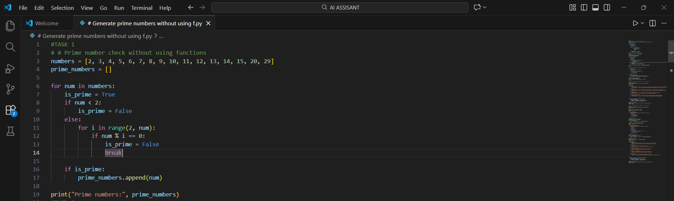
2️⃣ Task 2 – Optimizing Prime Check Code
👉 “Optimize this prime number checking code by reducing unnecessary iterations and improving efficiency. Use early termination where possible.”
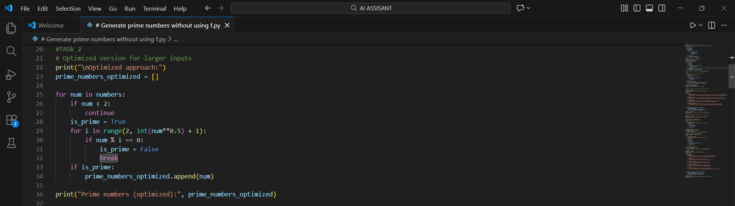
3️⃣ Task 3 – Function-Based Prime Checking
👉 “Create a Python program with a user-defined function that checks whether a number is prime and returns a Boolean value. Add meaningful comments.”
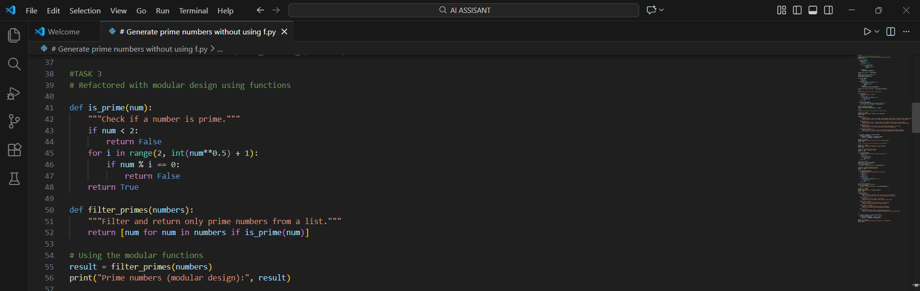
4️⃣ Task 4 – Comparison of Function vs Non-Function Code
👉 “Compare two Python programs for prime checking: one without functions and one with functions. Analyze code clarity, reusability, debugging ease, and scalability.”
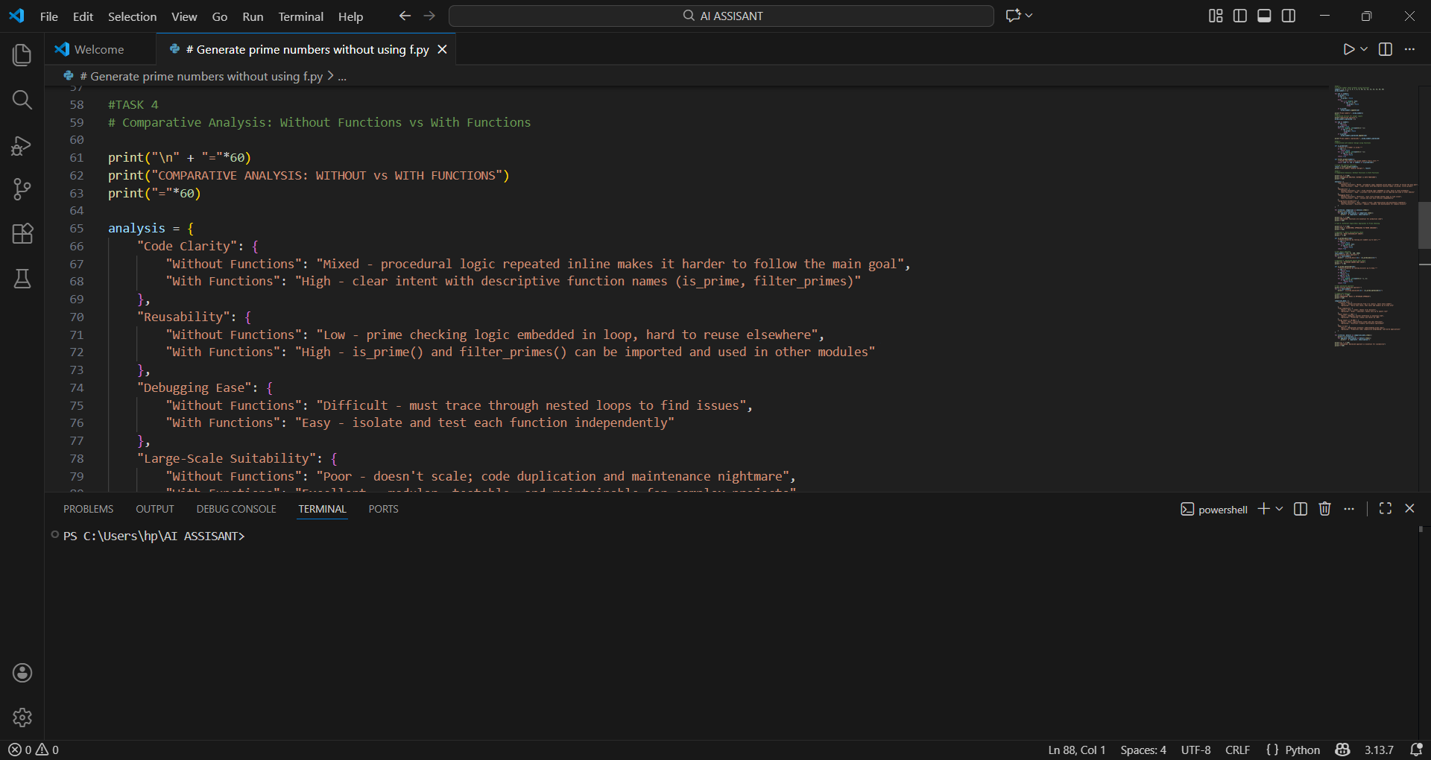
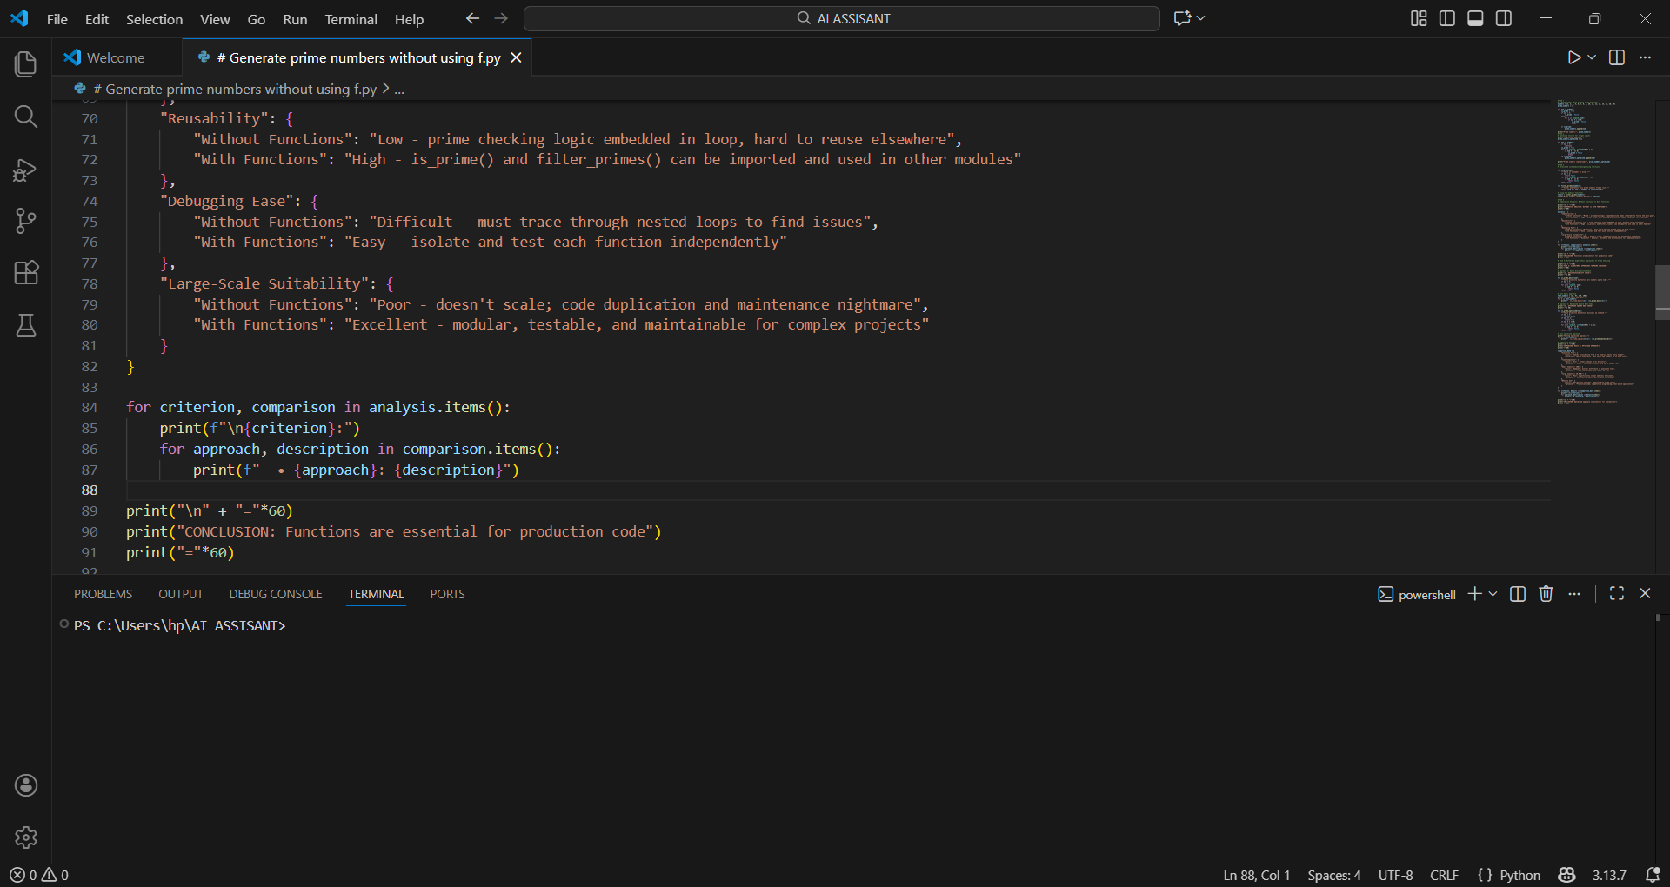
5️⃣ Task 5 – Basic vs Optimized Algorithmic Approaches
👉 “Generate two Python implementations for prime number checking: one using basic divisibility and another optimized by checking up to the square root of the number. Compare their performance.”
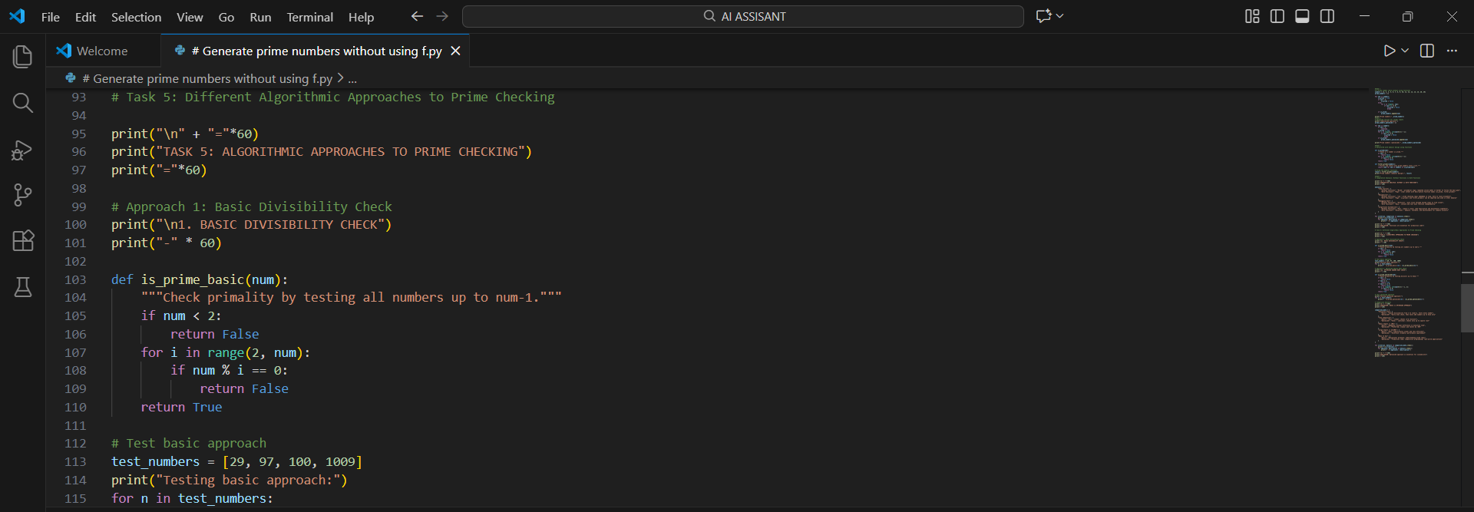
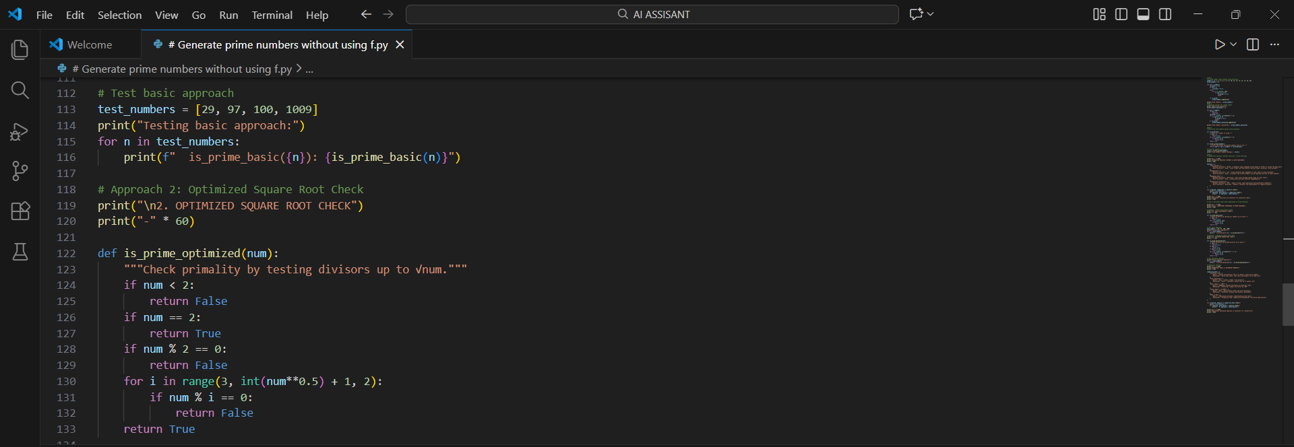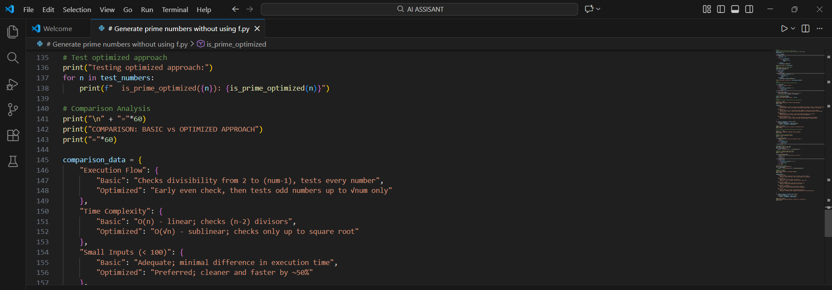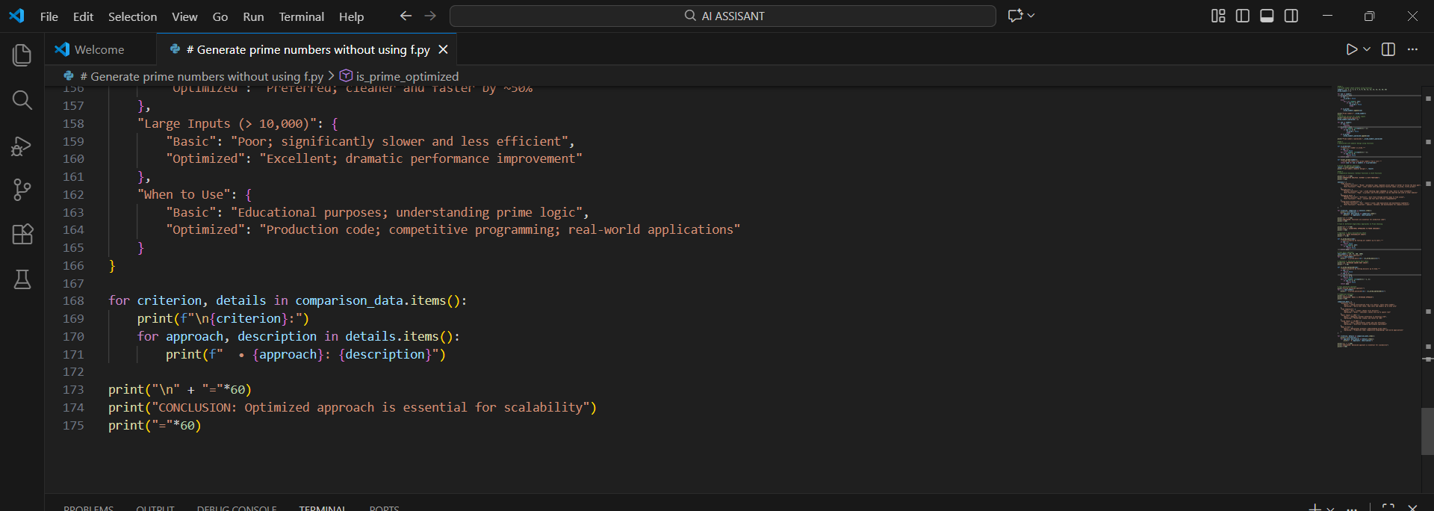
OUTPUTS:
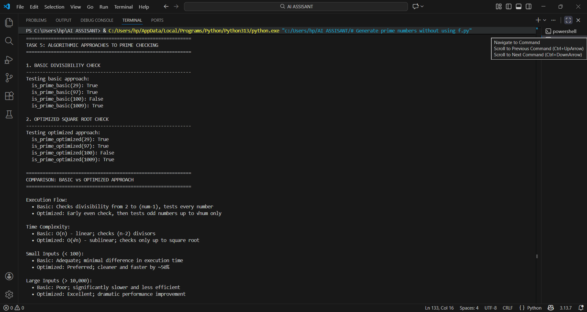

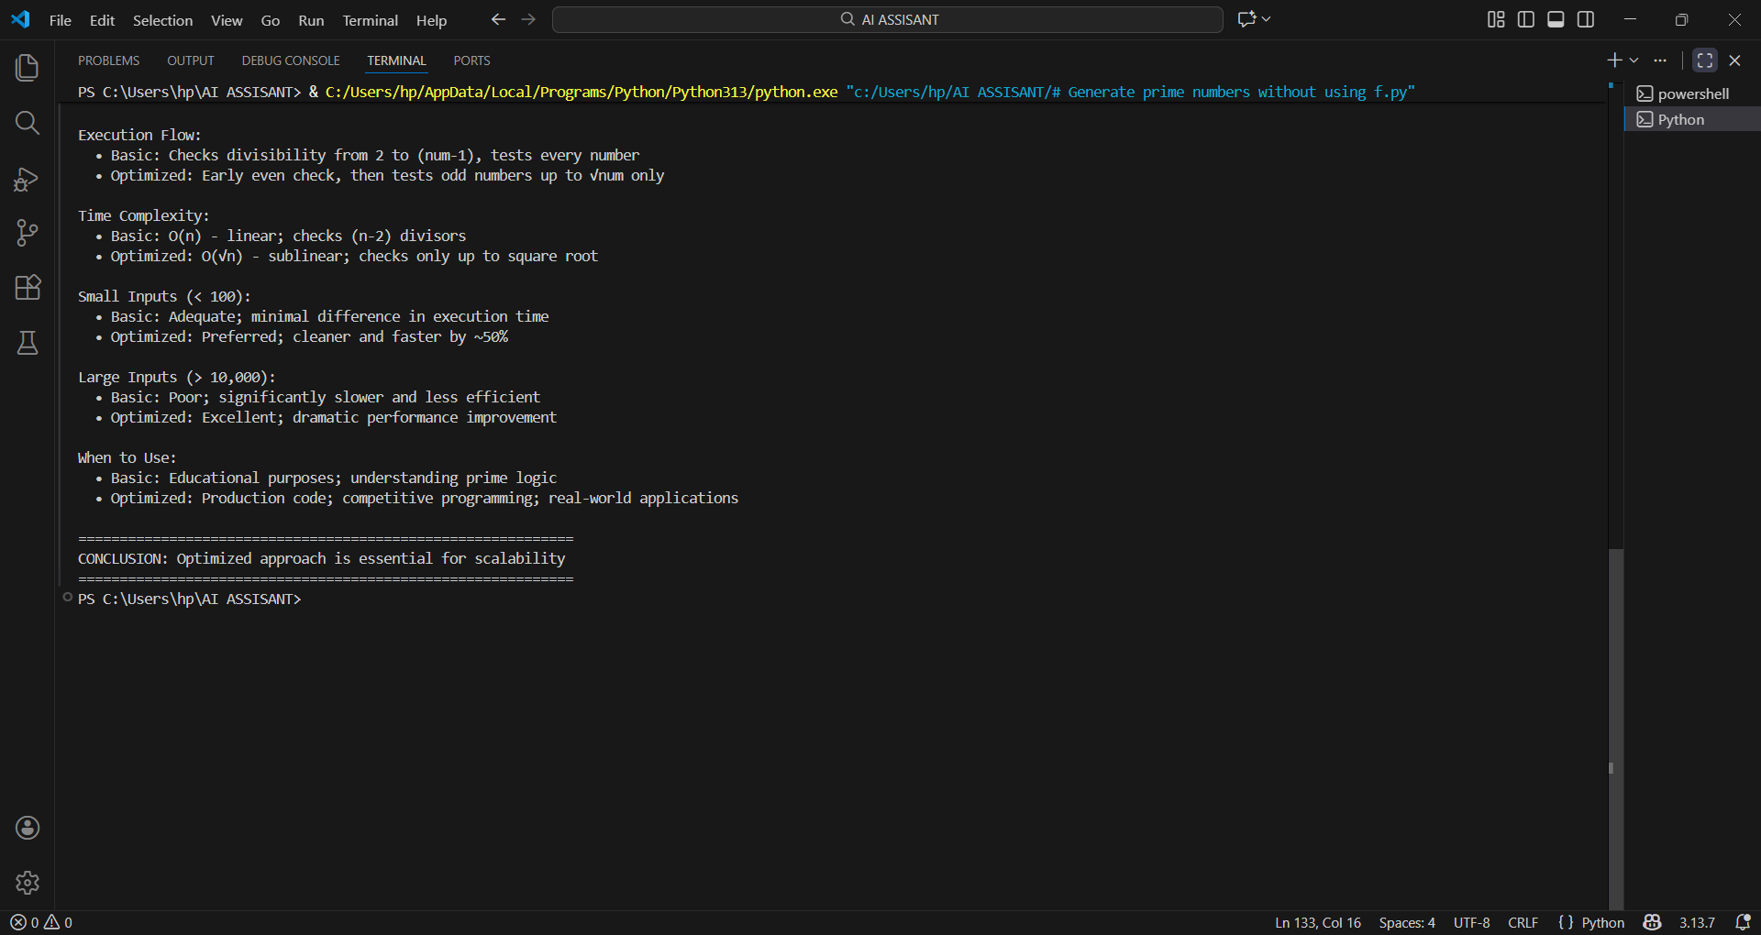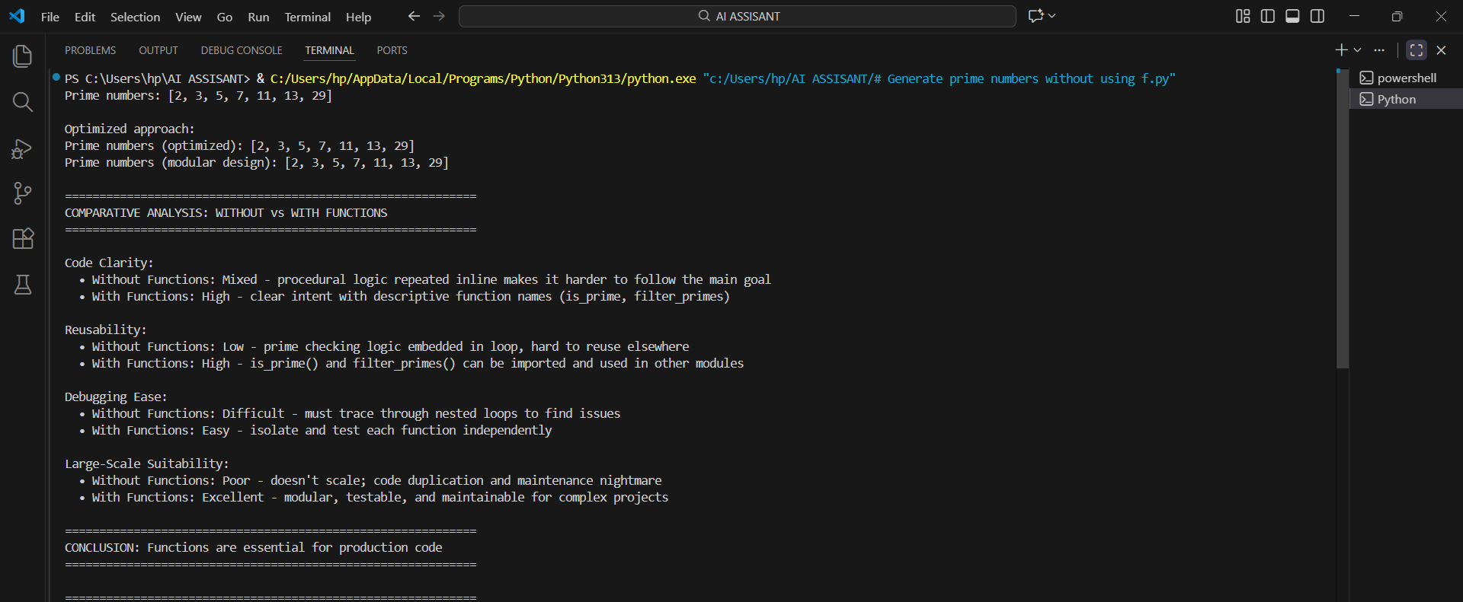

TASK-1 OBSERVATIONS
Task Description
Use GitHub Copilot to generate a Python program that:
➢ Checks whether a given number is prime
➢ Accepts user input
➢ Implements logic directly in the main code
➢ Does not use any user-defined functions GIVE DISCRPTION IN 4 LINES
TASK-2
This task focuses on refining the Copilot-generated prime-checking code to make it more efficient.
Unnecessary iterations are reduced by limiting checks to a smaller range and stopping early when a divisor is found.
The loop logic is optimized (such as checking only up to √n) to improve performance.
Overall readability is enhanced by clearer conditions and structured flow.
TASK-3
This task involves creating a Python program that uses a user-defined function to check whether a number is prime.
The function should return a Boolean value (True or False) based on the primality check.
User input is passed to the function, keeping the logic modular and reusable.
AI-assisted comments are included to clearly explain each step of the code.
TASK-4
This task compares Copilot-generated prime-checking programs written with and without user-defined functions.
The comparison focuses on code clarity, reusability, and ease of debugging.
Function-based code is generally cleaner and easier to maintain than inline logic.
The analysis also evaluates which approach is more suitable for large-scale applications.
TASK-5
This task involves prompting GitHub Copilot to generate two different prime-checking approaches.
The first approach uses a basic divisibility check by testing all possible factors.
The second approach applies an optimized strategy by checking divisibility only up to √n.
The goal is to compare logic efficiency and performance between the two methods.

